 **SAP Support**  
Customer Interaction Center

**Dear Supplier,**Thank you for contacting SAP Support.

There is a specific support process for SAP Ariba suppliers whereby they can request an immediate callback from the expert team to discuss the issue.

1. Access this link - [https://support.ariba.com/help](https://protect-za.mimecast.com/s/_ERTCr0poRCrmnvqu7lpB7?domain=support.ariba.com)
2. Select the Ariba Network tile

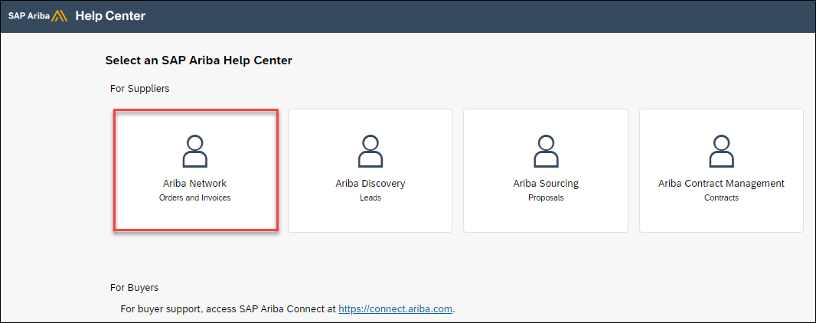

1. A screen will populate underneath where you can enter a brief description of your question and select search to get several articles that may help with your question.

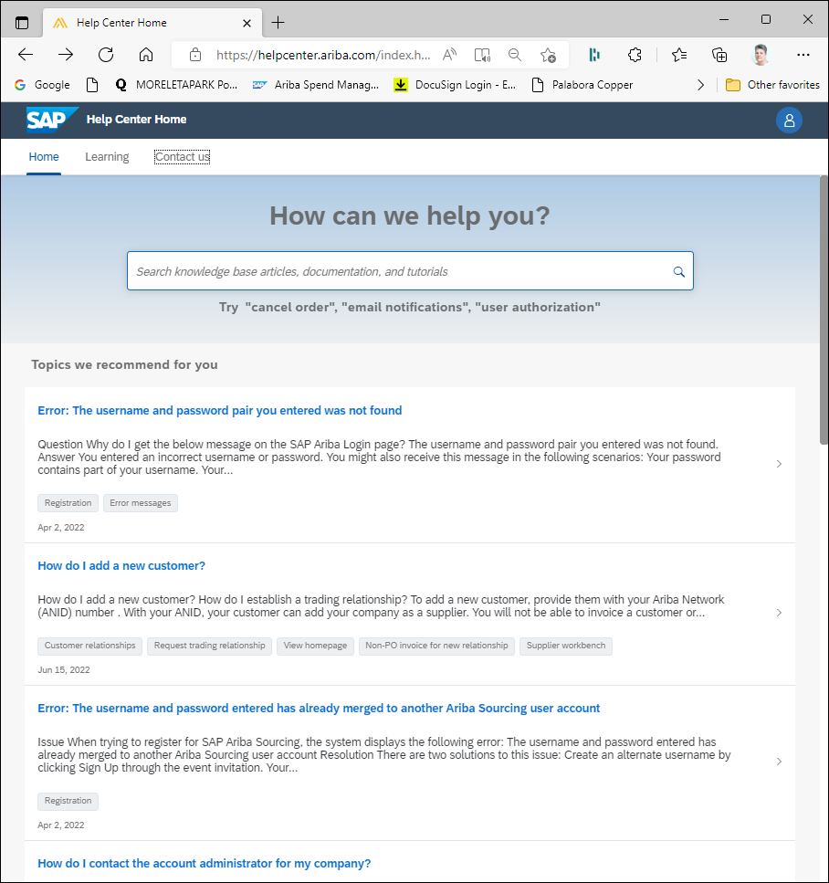

**If the articles are not related to your question, you can speak to an SAP Support Agent by clicking Contact Us located in the left-hand corner**



1. Select from one of four options that will appear on the screen.

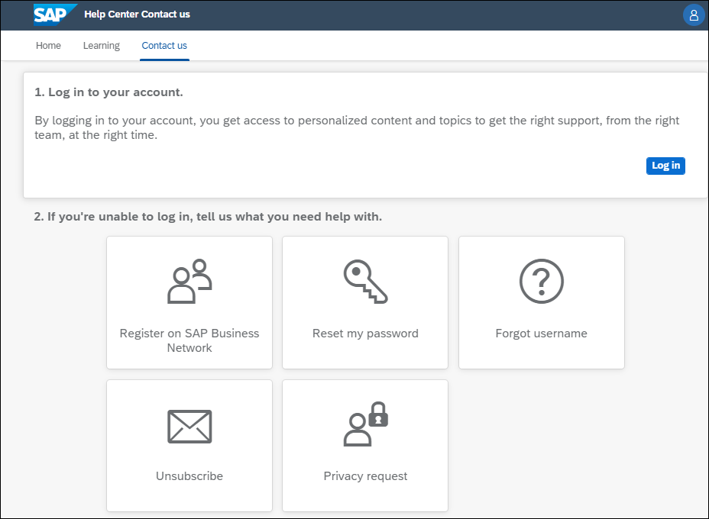

The four options provided may not be related to the question you have. If this is the case, select any of the options, and a new screen will appear that you then choose the I am experiencing something else option. Create a Case will be at the bottom right-hand corner of the screen.

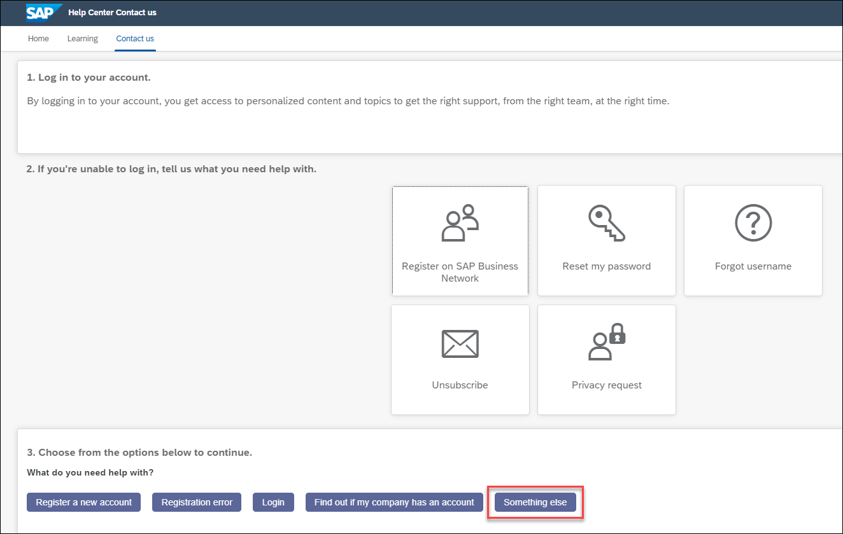

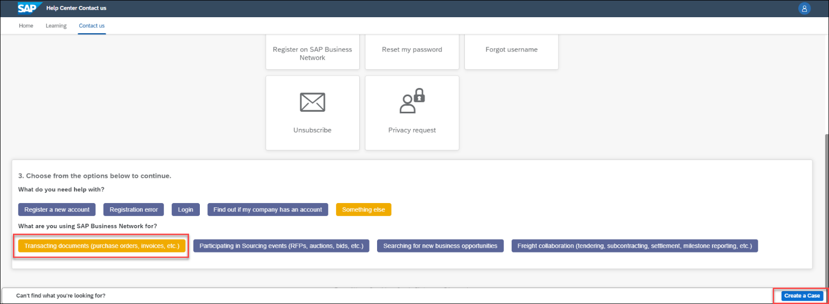

1. You will need to enter details about your issue and contact information. Please also provide your ANID number. You can find your SAP Ariba Network ID (ANID) number once you are logged into your SAP Ariba account, your account’s ANID number will appear if you click your initials > Settings in the upper-right corner of the application.

– 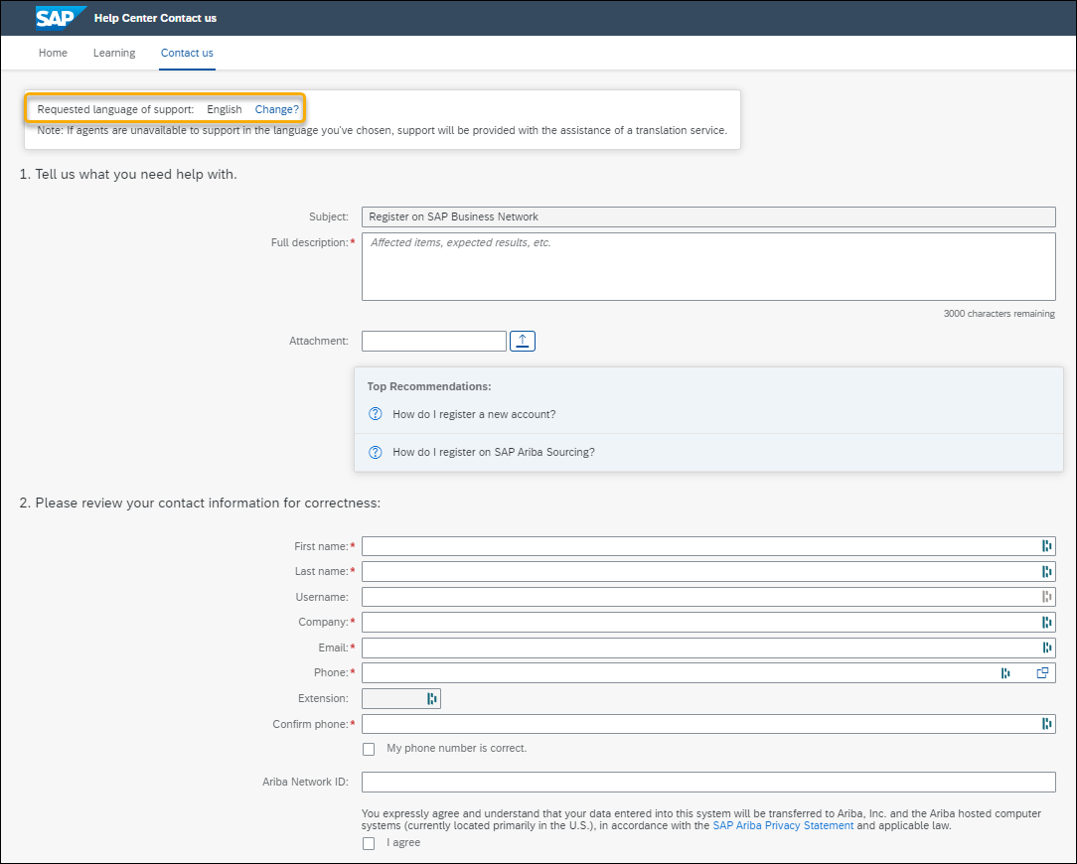

1. Once you provide your details you can select One Last Step at the bottom right corner.



1. Choose how you would like to be contacted by SAP Ariba Support and Submit

The full explanation of the process can be found here using this blog: [https://blogs.sap.com/2021/07/19/ariba-support-weve-got-you-covered/](https://protect-za.mimecast.com/s/bNBeCvgwvosElL69IXnHap?domain=blogs.sap.com/)

If you need any further assistance, please do not hesitate to contact us again.